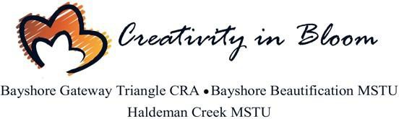

Bayshore Beautification MSTU Advisory Committee Meeting Calendar 2020
Meetings are held on the first Wednesday of each month at 5:00 PM unless otherwise notified
- January 7, 2020 – Joint Workshop CRA/MSTU’s
- February 5, 2020
- March 4, 2020
- April 7, 2020 Joint CRA/MSTU/BCC Annual workshop- 9am
- April 8, 2020 – 2nd Wednesday
- May 6, 2020
- June 3, 2020
- July 8, 2020 –2nd Wednesday due to Independence Day
- August 5, 2020- Summer Break (TBD)
- September 2, 2020- Summer Break (TBD)
- October 7, 2020
- November 4, 2020
- December 2, 2020

BCC Holiday Schedule 2020
The Board of County Commissioners recognizes the following holidays in 2020, observed on the dates listed below:

- New Year’s Day Wednesday, January 1, 2020
- Martin Luther King, Jr. Day Monday, January 20, 2020
- President’s Day Monday, February 17, 2020
- Memorial Day Monday, May 25, 2020
- Independence Day Friday, Observed July 3, 2020
- Labor Day Monday, September 7, 2020
- Veteran’s Day Wednesday, November 11, 2020
- Thanksgiving Day Thursday, November 26, 2020
- Day After Thanksgiving Friday, November 27, 2020
- Christmas Eve Thursday, December 24, 2020

Christmas Day Friday, December 25, 2020

Offices: 3299 Tamiami Trl E, Unit 103, Naples, Florida 34112
Phone: 239-252-8844
Online: www.bayshorecra.com

