[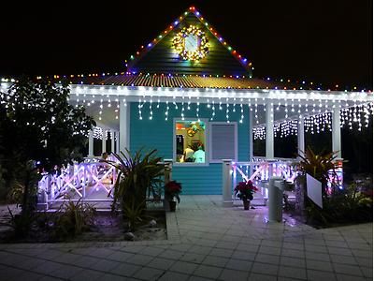](javascript:showImage('Caribbean%20Garden-%20Chattel%20House.jpg%20-%20Night%20Lights%20image','/show/night-lights-5/image/2008090514-290-10881-640x480/Caribbean+Garden-+Chattel+House.jpg',700,480,640,%20'Pluto___ProfileImagePortlet_T1_Images');)