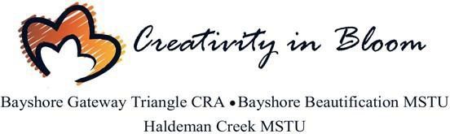

Haldeman Creek MSTU Advisory Committee Meeting Calendar 2021
Meetings are held on the first Monday of each month at 3:30 PM unless otherwise notified
- January 11, 2021 – 2nd Monday of the month due to New Years.
- February 1, 2021- TBD
- March 1, 2021 – TBD
- April 6, 2021 – BCC/CRA/MSTU Workshop TBD 9am
- April 5, 2021- TBD
- May 3, 2021- TBD
- June 7, 2021 – Summer Break
- July 12, 2021 – Summer Break -2nd Monday due to 4th of July Holiday
- August 2, 2021 - Summer Break
- September 13, 2021- Summer Break- 2nd Monday due to Labor Day
- October 4, 2021 –tentative
- November 1, 2021
- December 6, 2021

BCC Holiday Schedule 2021
The Board of County Commissioners recognizes the following holidays in 2021, observed on the dates listed below:
- New Year’s Day Friday, January 1, 2021
- Martin Luther King, Jr. Day Monday, January 18, 2021
- President’s Day Monday, February 15, 2021
- Memorial Day Monday, May 31, 2021
- Independence Day Monday, Observed July 5, 2021
- Labor Day Monday, September 6, 2021
- Veteran’s Day Thursday, November 11, 2021
- Thanksgiving Day Thursday, November 25, 2021
- Day After Thanksgiving Friday, November 26, 2021
- Christmas Eve Friday, December 24, 2021

Christmas Day Monday, December 27, 2021

Offices: 3299 Tamiami Trail E, Unit 103, Naples, Florida 34112
Phone: 239-252-8844
Online: www.bayshorecra.com

